Internal QA Report - 2023

## Breakdowns

All 20 Core Question Variables have been analysed and compared with SSCQ data for the last 4 publications (back to 2016 if necessary for some of the crime variables). The means and CIs have been calculated, ensuring that the weights have been taken into account. These have the been summarised in tables and then visualised in graphs (if the variable has factors/levels then each factor/level has been visualised in a separate graph). The tables and visualisations should help to see trends over time, as well as large differences in sampling/weighting/results between years for each variable.

# Variables

## 1. Age

### 1.1 Mean Age

This breakdown involved the continuous variable of age => the mean age for each SSCQ year was calculated (back to 2018).

SSCQ Respondent Average Age by Year

| Year | Average SSCQ Respondent Age by Year |
| --- | --- |
| 2023 | 49.1 ± 0.4 |
| 2022 | 48.7 ± 0.4 |
| 2019 | 48.4 ± 0.3 |
| 2018 | 48.3 ± 0.4 |

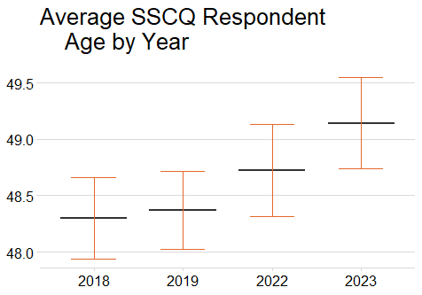

### 1.2 Age Groups

This breakdown looks at the more granular analysis of age distribution within and between each SSCQ year (back to 2018).

SSCQ Respondent Age Group by Year

| Year | Average SSCQ Respondent Age by Year |
| --- | --- |
| 2023 | 49.1 ± 0.4 |
| 2022 | 48.7 ± 0.4 |
| 2019 | 48.4 ± 0.3 |
| 2018 | 48.3 ± 0.4 |

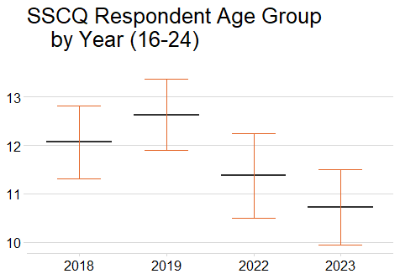

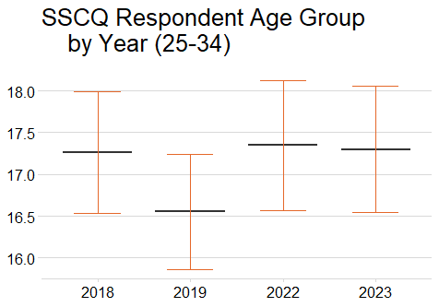

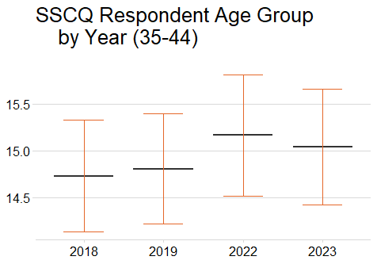

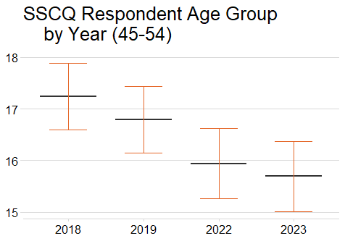

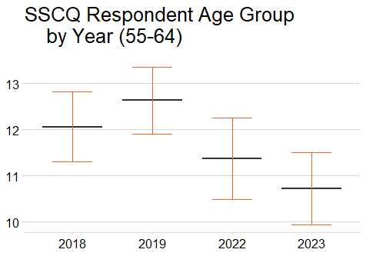

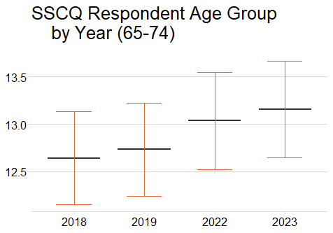

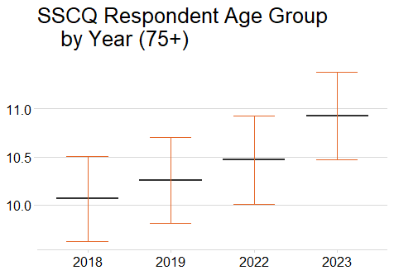

## 2. Sex

The following breakdowns show the proportion of male and female respondents in the SSCQ data since 2018.

SSCQ Respondent Sex by Year

| Year | Male | Female |
| --- | --- | --- |
| 2023 | 48.1 ± 0.9 | 51.9 ± 0.9 |
| 2022 | 48.3 ± 0.9 | 51.7 ± 0.9 |
| 2019 | 48.2 ± 0.8 | 51.8 ± 0.8 |
| 2018 | 48.2 ± 0.8 | 51.8 ± 0.8 |

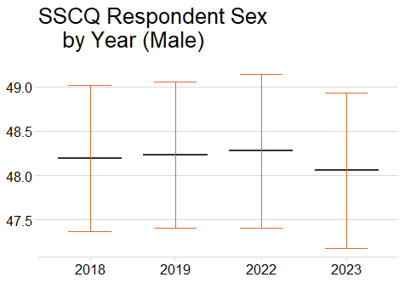

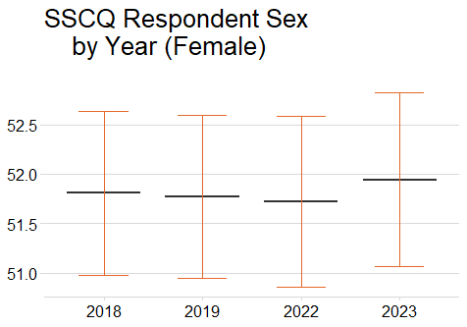

## 3. Trans Status

This variable was only added to the Core Questions in 2022, so only 2 SSCQ years can be compared.

SSCQ Respondent Trans Status by Year

| Year | No: Not trans and does not have a trans history | Yes: Trans or has a trans history |
| --- | --- | --- |
| 2023 | 92.1 ± 1 | 0.3 ± 0.1 |
| 2022 | 94.2 ± 0.7 | 0.2 ± 0.1 |

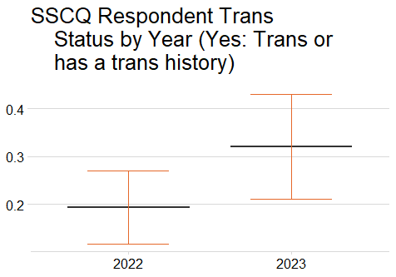

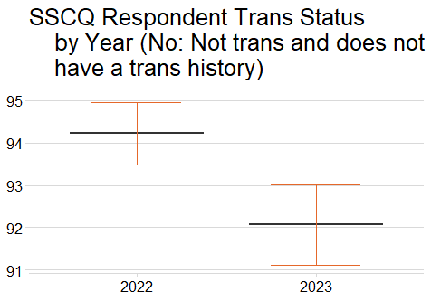

## 4. Household Type

This variable gives a more granular analysis of the types of households in the SSCQ data => who makes up the households.

SSCQ Respondent Household Type by Year

| Year | Single Adult | Small Adult | Large Adult | Single Parent | Small Family | Large Family | Single Pensioner | Older Couple |
| --- | --- | --- | --- | --- | --- | --- | --- | --- |
| 2023 | 18.7 ± 0.7 | 16.5 ± 0.6 | 9.1 ± 0.5 | 4.3 ± 0.4 | 12.3 ± 0.5 | 5.1 ± 0.4 | 17.2 ± 0.6 | 16.9 ± 0.6 |
| 2022 | 19.2 ± 0.7 | 16.3 ± 0.6 | 9.3 ± 0.5 | 4.3 ± 0.3 | 12.2 ± 0.5 | 5.3 ± 0.4 | 16.8 ± 0.6 | 16.6 ± 0.5 |
| 2019 | 18.1 ± 0.7 | 17.5 ± 0.6 | 9.4 ± 0.5 | 4.3 ± 0.3 | 12.7 ± 0.5 | 5.3 ± 0.3 | 16.5 ± 0.6 | 16.2 ± 0.5 |
| 2018 | 19.1 ± 0.7 | 17.4 ± 0.6 | 9.2 ± 0.5 | 4.5 ± 0.3 | 12.5 ± 0.5 | 5.2 ± 0.3 | 15.9 ± 0.5 | 16.2 ± 0.5 |

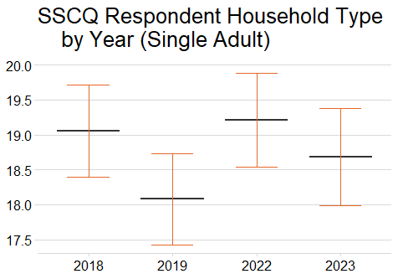

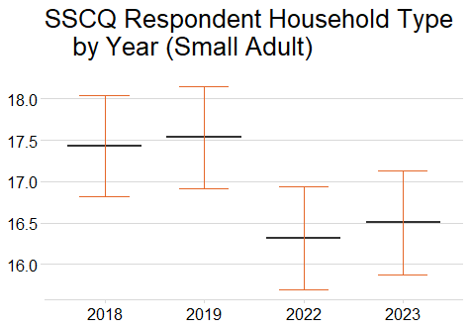

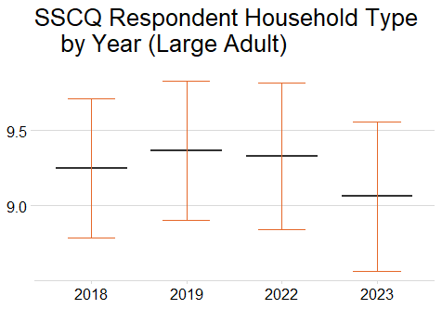

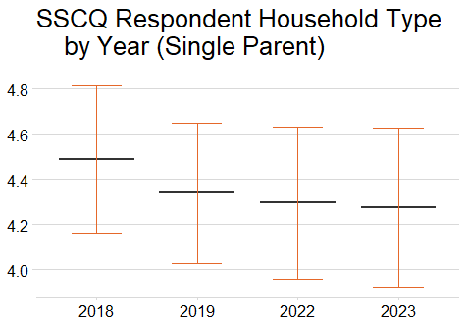

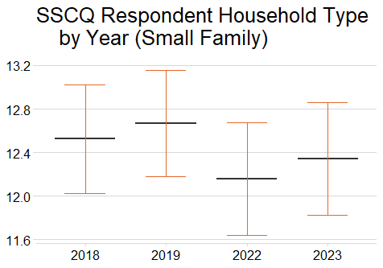

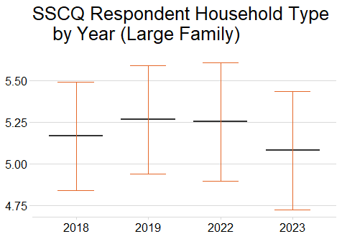

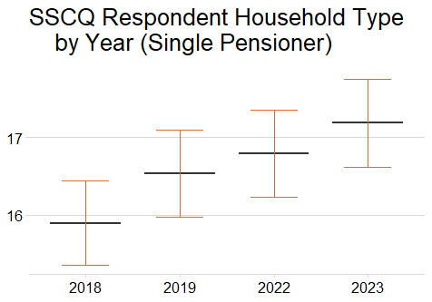

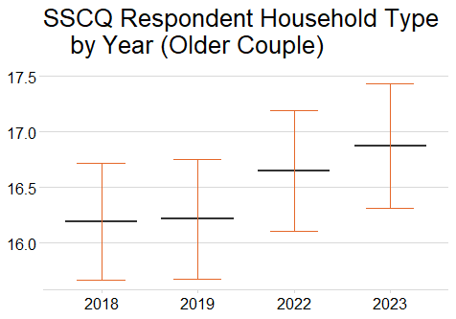

## 5. Tenure

This variable offers insight into the tenure type that SSCQ respondents currently have.

SSCQ Respondent Tenure Type by Year

| Year | Buying with the help of a mortgage or loan | Own outright (i.e. no mortgage or loan) | Pay part rent and part mortgage (shared ownership) | Renting (including in receipt of housing benefit) | Living here rent free |
| --- | --- | --- | --- | --- | --- |
| 2023 | 26.9 ± 0.7 | 36.2 ± 0.8 | 1.1 ± 0.2 | 34.5 ± 0.8 | 1.1 ± 0.2 |
| 2022 | 28.1 ± 0.7 | 35.4 ± 0.7 | 0.9 ± 0.2 | 34.2 ± 0.8 | 1.1 ± 0.2 |
| 2019 | 27.9 ± 0.7 | 33.5 ± 0.7 | 0.7 ± 0.1 | 36.4 ± 0.8 | 1.2 ± 0.2 |
| 2018 | 28.2 ± 0.7 | 32.9 ± 0.7 | 0.9 ± 0.1 | 36.6 ± 0.8 | 1.3 ± 0.2 |

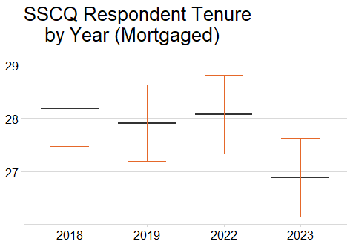

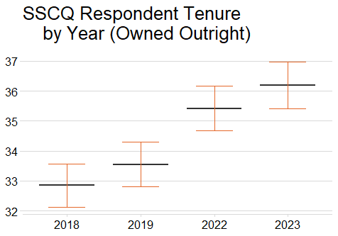

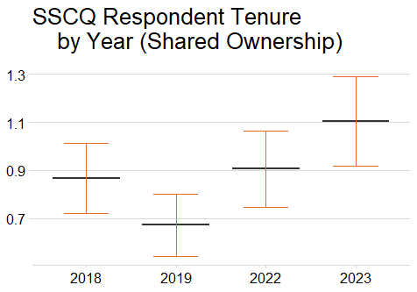

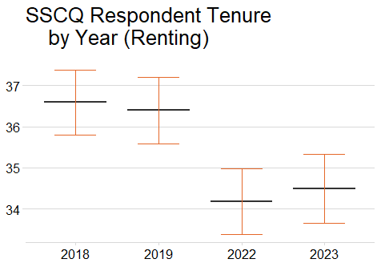

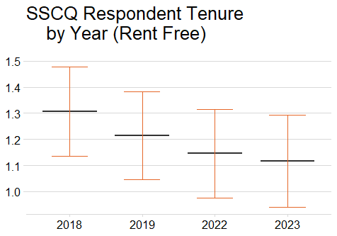

## 6. Car Access

This variable highlights the access to cars that SSCQ respondents currently have. Broken down further into how many cars they have if they do have access.

SSCQ Respondent Car Access by Year

| Year | No car | 1 car | 2 cars | 3 or more cars |
| --- | --- | --- | --- | --- |
| 2023 | 26.5 ± 0.8 | 43.4 ± 0.8 | 23.8 ± 0.7 | 6.3 ± 0.4 |
| 2022 | 25.4 ± 0.7 | 44.8 ± 0.8 | 23.7 ± 0.7 | 6.2 ± 0.4 |
| 2019 | 27.5 ± 0.7 | 42 ± 0.8 | 24.2 ± 0.7 | 6.2 ± 0.4 |
| 2018 | 28.2 ± 0.7 | 42.3 ± 0.8 | 23.4 ± 0.7 | 6.1 ± 0.4 |

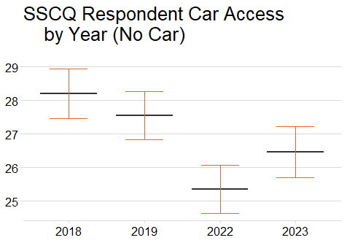

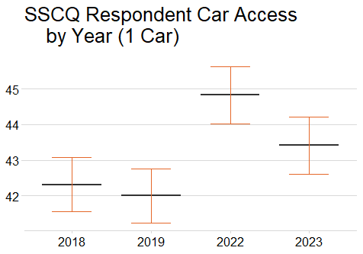

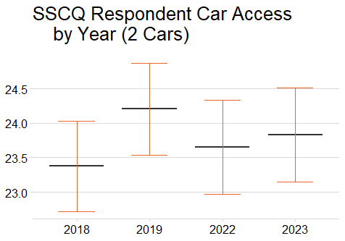

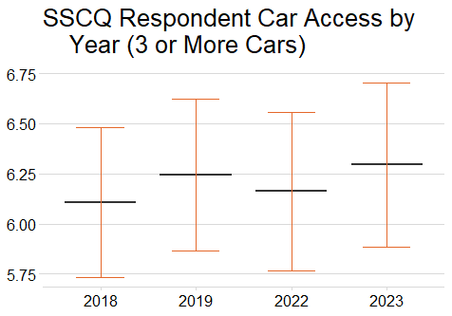

## 7. Country of Birth

This variable offers insight into where in the world the SSCQ respondents were born => does not necessarily indicate nationality.

SSCQ Respondent Country of Birth by Year

| Year | Scotland | Rest of UK | EU27 | Rest of World |
| --- | --- | --- | --- | --- |
| 2023 | 74.8 ± 0.9 | 12.3 ± 0.6 | 3.6 ± 0.4 | 5.9 ± 0.5 |
| 2022 | 74.9 ± 0.9 | 12.5 ± 0.6 | 3.2 ± 0.4 | 4.8 ± 0.6 |
| 2019 | 77.3 ± 0.8 | 11.5 ± 0.6 | 5.2 ± 0.4 | 5.9 ± 0.5 |
| 2018 | 77.8 ± 0.8 | 11.6 ± 0.6 | 5.4 ± 0.4 | 5.1 ± 0.4 |

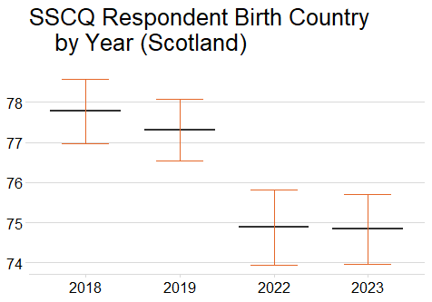

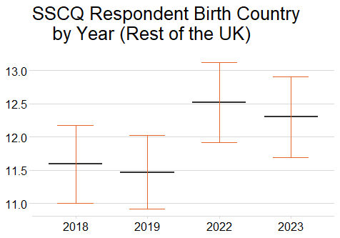

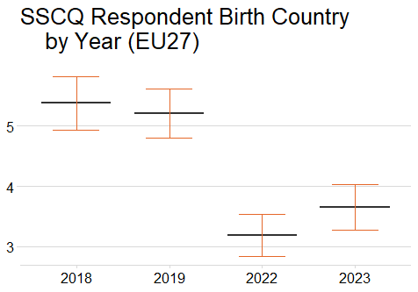

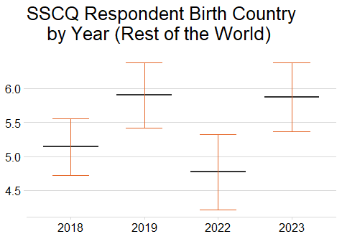

## 8. Religion

This variable breaks down which (if any) religion that the SSCQ respondents identify with.

SSCQ Respondent Religion by Year

| Year | No religion | Church of Scotland | Roman Catholic | Other Christian | Muslim | Other |
| --- | --- | --- | --- | --- | --- | --- |
| 2023 | 58.5 ± 0.9 | 18.9 ± 0.7 | 12 ± 0.6 | 6.3 ± 0.5 | 2 ± 0.3 | 2.1 ± 0.3 |
| 2022 | 58 ± 0.9 | 19.8 ± 0.7 | 12.1 ± 0.6 | 5.6 ± 0.4 | 1.8 ± 0.4 | 2.3 ± 0.3 |
| 2019 | 53.7 ± 0.9 | 21.5 ± 0.7 | 13.6 ± 0.6 | 7.4 ± 0.4 | 1.8 ± 0.3 | 1.8 ± 0.2 |
| 2018 | 50.2 ± 0.9 | 23.2 ± 0.7 | 14.2 ± 0.6 | 8.6 ± 0.5 | 1.6 ± 0.3 | 1.9 ± 0.2 |

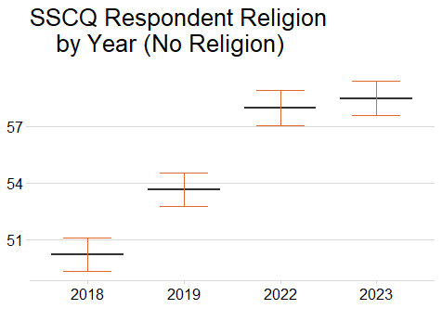

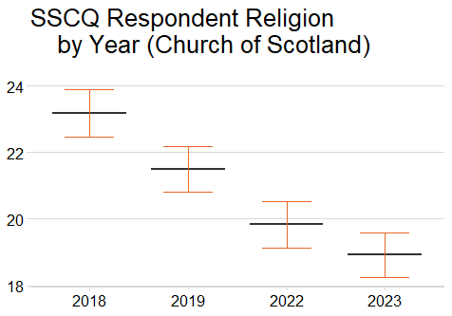

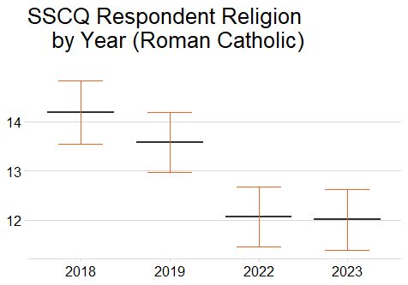

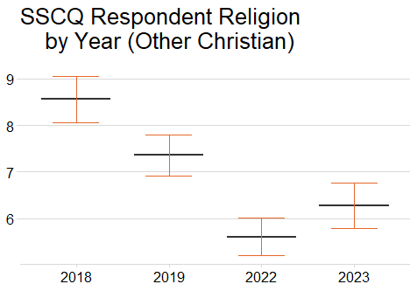

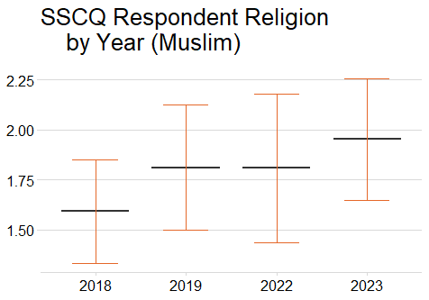

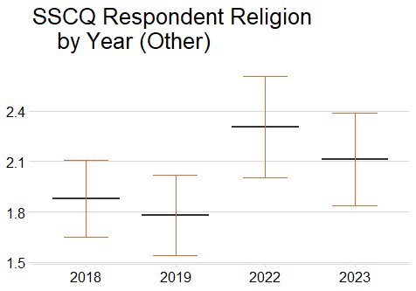

## 9. Ethnic Group

Offers insight into how the SSCQ respondents identify regarding their ethnicity.

SSCQ Respondent Ethnicity by Year

| Year | White: Scottish | White: Other British | White: Polish | White: Other | Asian | All other ethnic groups |
| --- | --- | --- | --- | --- | --- | --- |
| 2023 | 73.3 ± 0.9 | 12.9 ± 0.6 | 1.1 ± 0.2 | 3.8 ± 0.4 | 5.6 ± 0.5 | 3.3 ± 0.4 |
| 2022 | 73.1 ± 1 | 13.7 ± 0.6 | 1.2 ± 0.2 | 3 ± 0.3 | 5.6 ± 0.5 | 3.4 ± 0.5 |
| 2019 | 75.9 ± 0.8 | 12.5 ± 0.6 | 1.9 ± 0.3 | 4.9 ± 0.4 | 2.9 ± 0.3 | 2 ± 0.3 |
| 2018 | 76.7 ± 0.8 | 12.1 ± 0.6 | 1.6 ± 0.2 | 5 ± 0.4 | 2.8 ± 0.3 | 1.8 ± 0.3 |

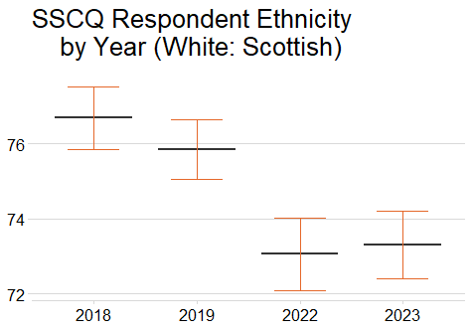

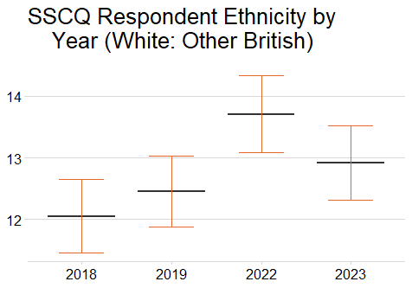

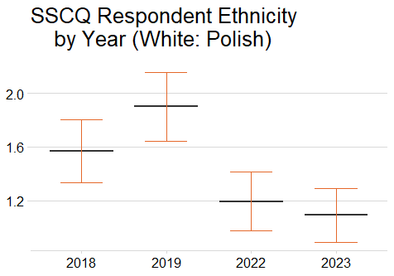

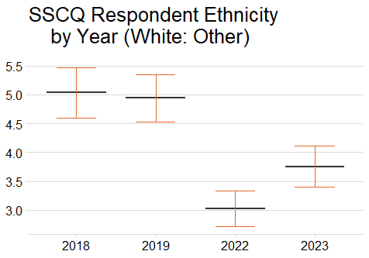

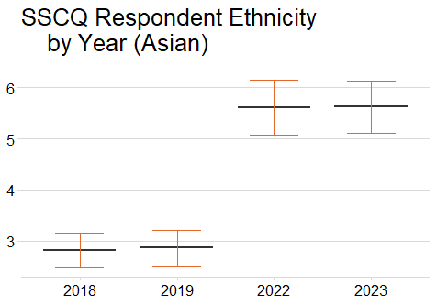

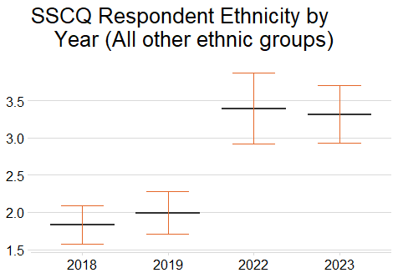

## 10. Sexual Orientation

Offers insight into how the SSCQ respondents identify regarding their sexuality.

SSCQ Respondent Sexual Orientation by Year

| Year | Heterosexual | LGB+ |
| --- | --- | --- |
| 2023 | 96.3 ± 0.4 | 3.7 ± 0.4 |
| 2022 | 95.7 ± 0.5 | 4.3 ± 0.5 |
| 2019 | 97 ± 0.3 | 3 ± 0.3 |
| 2018 | 97.4 ± 0.3 | 2.6 ± 0.3 |

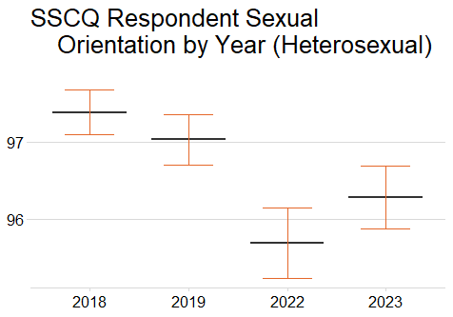

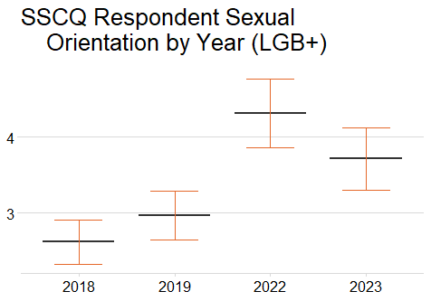

## 11. General Health

This variable highlights how SSCQ respondents feel about their overall health.

SSCQ Respondent General Health by Year

| Year | Very Good | Good | Fair | Bad | Very Bad |
| --- | --- | --- | --- | --- | --- |
| 2023 | 29.2 ± 0.9 | 43 ± 0.9 | 19.8 ± 0.7 | 6.1 ± 0.4 | 1.7 ± 0.2 |
| 2022 | 30.1 ± 0.9 | 42 ± 0.9 | 19.7 ± 0.7 | 6.3 ± 0.4 | 1.6 ± 0.2 |
| 2019 | 34.4 ± 0.9 | 37.6 ± 0.8 | 19.8 ± 0.7 | 6.3 ± 0.4 | 1.8 ± 0.2 |
| 2018 | 34.1 ± 0.9 | 38.6 ± 0.8 | 19.1 ± 0.6 | 6.2 ± 0.4 | 1.8 ± 0.2 |

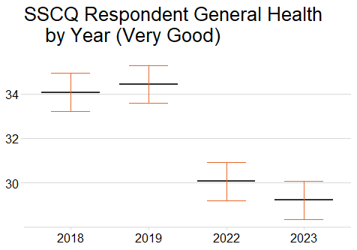

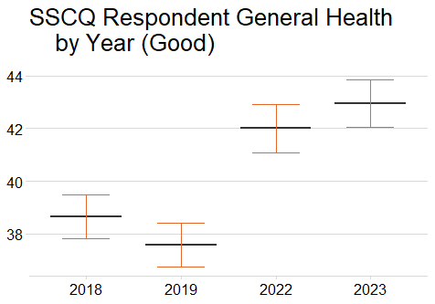

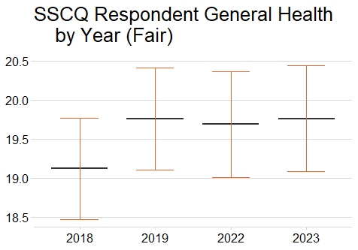

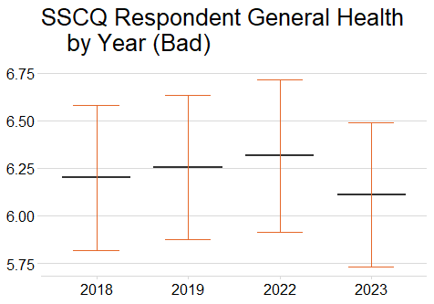

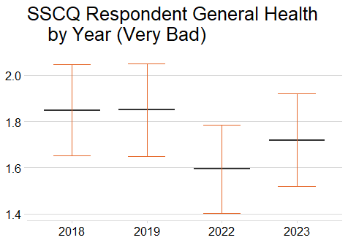

## 12. Long-Term Condition

This variable offers insight about whether SSCQ respondents identify that they are living with a long-term condition.

SSCQ Respondent Long-Term Condition by Year

| Year | Yes | No |
| --- | --- | --- |
| 2023 | 28 ± 0.8 | 71.5 ± 0.8 |
| 2022 | 27.1 ± 0.8 | 72.4 ± 0.8 |
| 2019 | 25.9 ± 0.7 | 73.7 ± 0.7 |
| 2018 | 24.7 ± 0.7 | 75 ± 0.7 |

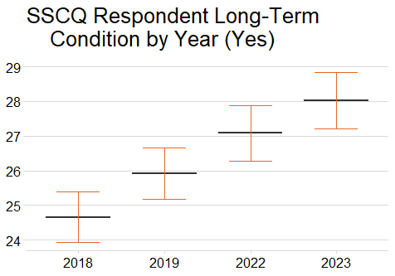

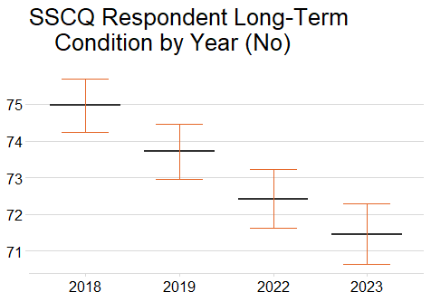

## 13. Smoking Status

Offers insight into how the SSCQ respondents identify regarding their smoking status.

SSCQ Respondent Smoking Status by Year

| Year | Yes | No |
| --- | --- | --- |
| 2023 | 12.8 ± 0.6 | 87.1 ± 0.6 |
| 2022 | 13.8 ± 0.6 | 86.1 ± 0.6 |
| 2019 | 17.5 ± 0.7 | 82.5 ± 0.7 |
| 2018 | 17.8 ± 0.7 | 82.2 ± 0.7 |

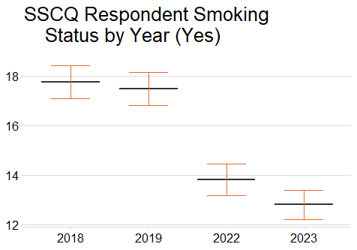

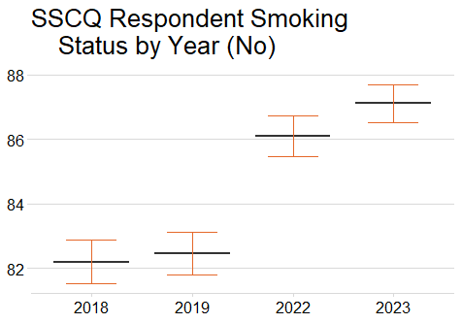

## 14. Mental Wellbeing

This is a continuous variable, that is able to offer limited insight into any possible trends in mental wellbeing. This variable was not reported on in 2019 and 2018, so the comparison goes back to 2016.

SSCQ Respondent Average Mental Wellbeing by Year

| Year | Average SSCQ Respondent Mental Wellbeing Score by Year |
| --- | --- |
| 2023 | 24.4 ± 0.1 |
| 2022 | 23.8 ± 0.1 |
| 2017 | 24.2 ± 0.1 |
| 2016 | 24.3 ± 0.1 |

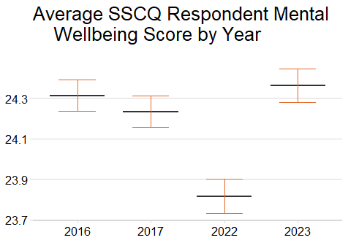

## 15. Provision of Unpaid Care

This variable highlights the proportion of SSCQ respondents who provide unpaid care.

SSCQ Respondent Provision of Unpaid Care by Year

| Year | Yes | No |
| --- | --- | --- |
| 2023 | 16.5 ± 0.7 | 83.4 ± 0.7 |
| 2022 | 19.3 ± 0.7 | 80.6 ± 0.7 |
| 2019 | 16.1 ± 0.6 | 83.8 ± 0.6 |
| 2018 | 18.4 ± 0.7 | 81.5 ± 0.7 |

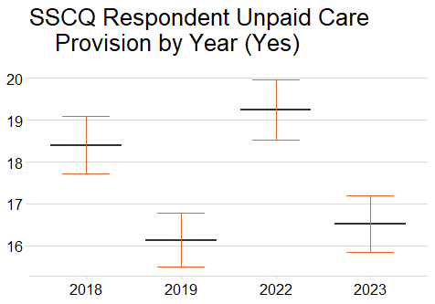

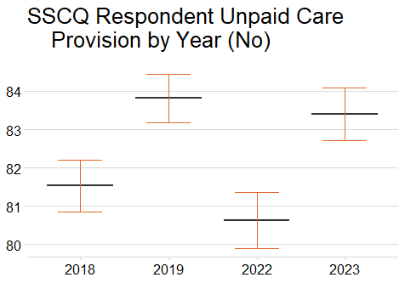

## 16. Perception of Local Crime Rate

This variable is able to show what SSCQ respondents think about their local area regarding crime rates and how they have changed.

SSCQ Respondent Perception of Local Crime Rate by Year

| Year | A lot more | A little more | About the same | A little less | A lot less |
| --- | --- | --- | --- | --- | --- |
| 2023 | 4.1 ± 0.4 | 12.9 ± 0.7 | 59 ± 1 | 4.1 ± 0.4 | 0.5 ± 0.1 |
| 2022 | 4 ± 0.4 | 11.7 ± 0.6 | 58.8 ± 1 | 5.2 ± 0.4 | 0.9 ± 0.2 |
| 2019 | 4.7 ± 0.4 | 12.9 ± 0.6 | 57.4 ± 0.9 | 4.7 ± 0.4 | 1 ± 0.2 |
| 2018 | 4.7 ± 0.4 | 12 ± 0.6 | 56.1 ± 0.9 | 5.5 ± 0.4 | 1.3 ± 0.2 |

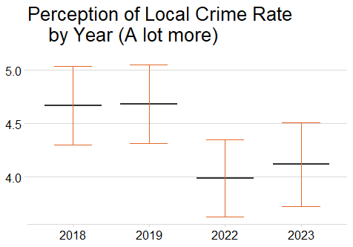

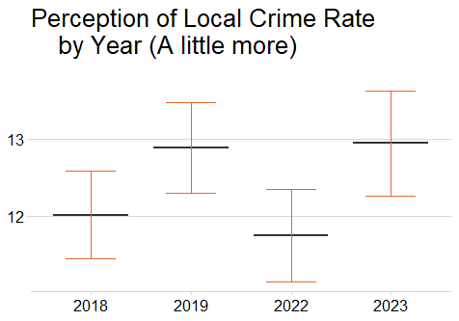

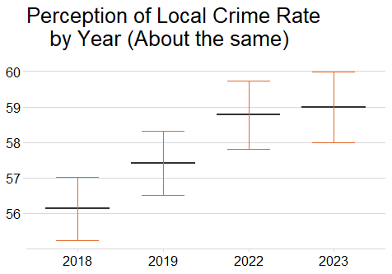

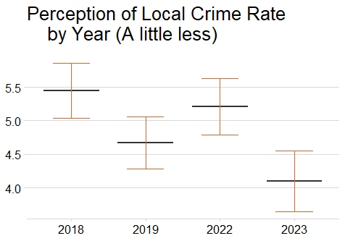

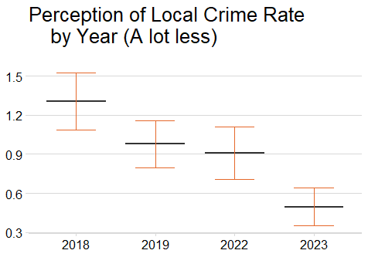

## 17. Police Confidence

This variable offers insight into the confidence that SSCQ respondents have in the Police. It is broken down into 5 further sub-variables. This variable was not reported on in 2019 and 2018, so the comparison goes back to 2016.

### 17.1 Police Confidence A: Prevent Crime

SSCQ Respondent Police Confidence A by Year (Prevent Crime)

| Year | Very confident | Fairly confident | Not very confident | Not at all confident |
| --- | --- | --- | --- | --- |
| 2023 | 6.4 ± 0.5 | 37.6 ± 1 | 26.2 ± 0.9 | 12.5 ± 0.7 |
| 2022 | 6.8 ± 0.5 | 41.6 ± 1 | 30 ± 0.9 | 10.1 ± 0.6 |
| 2017 | 8.8 ± 0.6 | 47 ± 0.9 | 26.8 ± 0.8 | 8.2 ± 0.5 |
| 2016 | 9.6 ± 0.6 | 47.9 ± 0.9 | 25.7 ± 0.8 | 7.8 ± 0.5 |

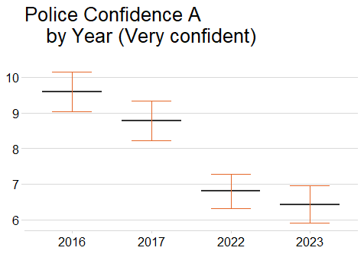

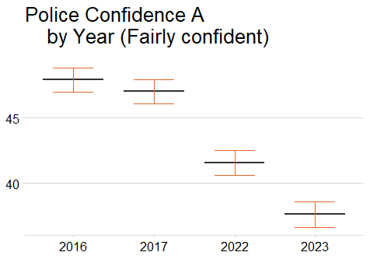

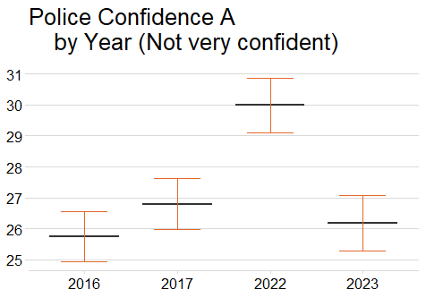

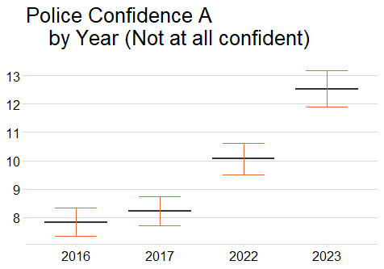

### 17.2 Police Confidence B: Respond quickly to appropriate calls and information from the public

SSCQ Respondent Police Confidence B by Year (Respond Quickly)

| Year | Very confident | Fairly confident | Not very confident | Not at all confident |
| --- | --- | --- | --- | --- |
| 2023 | 10.4 ± 0.6 | 45 ± 1 | 19.3 ± 0.8 | 10.1 ± 0.6 |
| 2022 | 12.6 ± 0.7 | 46.5 ± 1 | 21.6 ± 0.8 | 8.8 ± 0.5 |
| 2017 | 15.6 ± 0.7 | 49.3 ± 0.9 | 19.6 ± 0.7 | 7.2 ± 0.5 |
| 2016 | 17.1 ± 0.7 | 48.9 ± 0.9 | 18.4 ± 0.7 | 7.1 ± 0.5 |

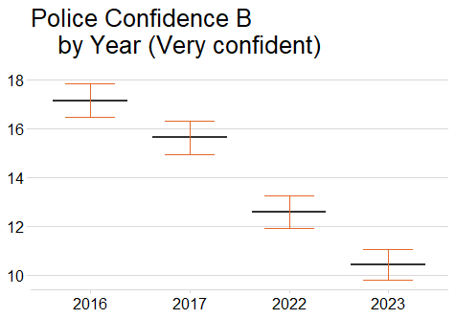

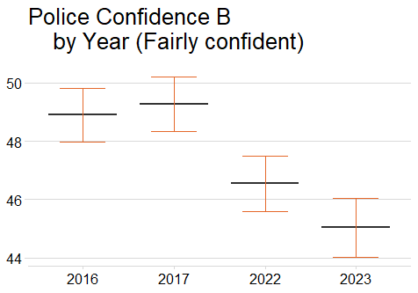

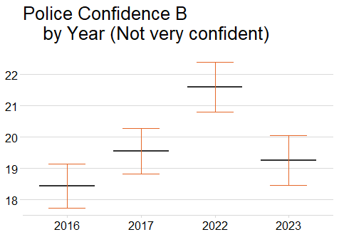

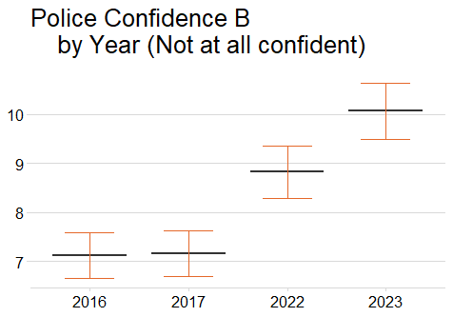

### 17.3 Police Confidence C: Deal with incidents as they occur

SSCQ Respondent Police Confidence C by Year (Deal with Incidents)

| Year | Very confident | Fairly confident | Not very confident | Not at all confident |
| --- | --- | --- | --- | --- |
| 2023 | 8.7 ± 0.6 | 45.8 ± 1 | 20.1 ± 0.8 | 9.7 ± 0.6 |
| 2022 | 10.5 ± 0.6 | 49.1 ± 1 | 21.9 ± 0.8 | 7.9 ± 0.5 |
| 2017 | 12.9 ± 0.6 | 53.8 ± 0.9 | 19.1 ± 0.7 | 6.4 ± 0.4 |
| 2016 | 14.5 ± 0.7 | 53.4 ± 0.9 | 18.2 ± 0.7 | 6.2 ± 0.4 |

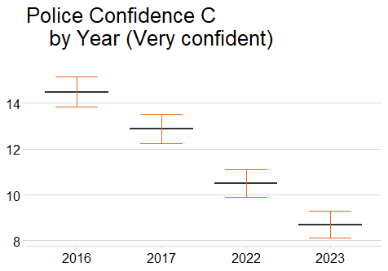

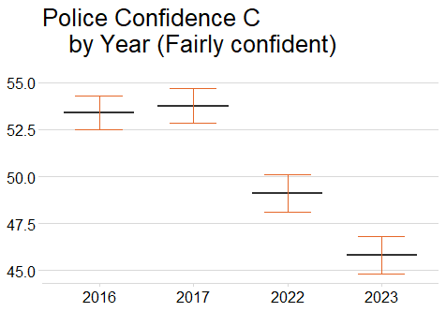

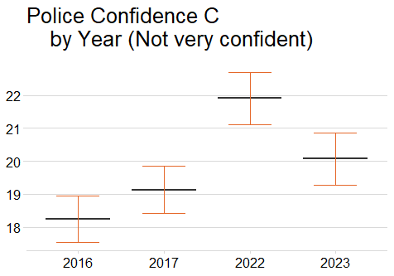

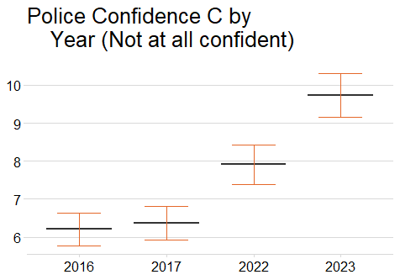

### 17.4 Police Confidence D: Investigate incidents after they occur

SSCQ Respondent Police Confidence D by Year (Inverstigate Incidents)

| Year | Very confident | Fairly confident | Not very confident | Not at all confident |
| --- | --- | --- | --- | --- |
| 2023 | 9.7 ± 0.6 | 46.7 ± 1 | 18.7 ± 0.8 | 8.1 ± 0.5 |
| 2022 | 10.4 ± 0.6 | 51.9 ± 1 | 19.7 ± 0.8 | 6.5 ± 0.5 |
| 2017 | 14 ± 0.7 | 55.3 ± 0.9 | 16.9 ± 0.7 | 4.5 ± 0.4 |
| 2016 | 15.1 ± 0.7 | 55.7 ± 0.9 | 15.7 ± 0.6 | 4.7 ± 0.4 |

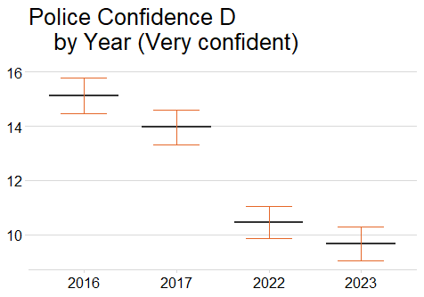

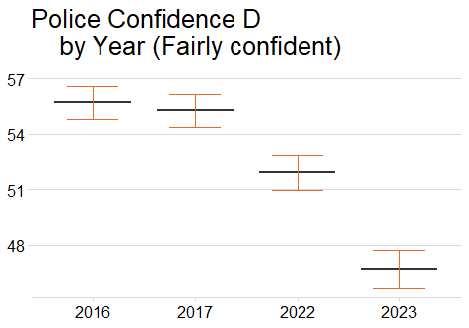

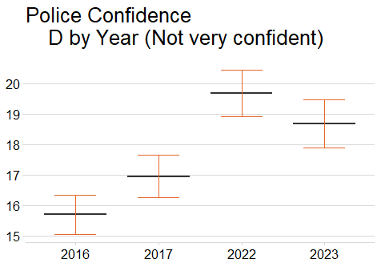

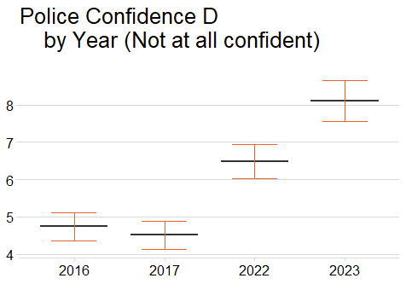

### 17.5 Police Confidence E: Solve crimes

SSCQ Respondent Police Confidence E by Year (Solve Crimes)

| Year | Very confident | Fairly confident | Not very confident | Not at all confident |
| --- | --- | --- | --- | --- |
| 2023 | 6.9 ± 0.5 | 43.4 ± 1 | 21.6 ± 0.8 | 8.3 ± 0.5 |
| 2022 | 7.8 ± 0.5 | 48.7 ± 1 | 22.9 ± 0.8 | 7 ± 0.5 |
| 2017 | 9.2 ± 0.6 | 54.4 ± 0.9 | 19.5 ± 0.7 | 5 ± 0.4 |
| 2016 | 10.3 ± 0.6 | 54.3 ± 0.9 | 19 ± 0.7 | 5.3 ± 0.4 |

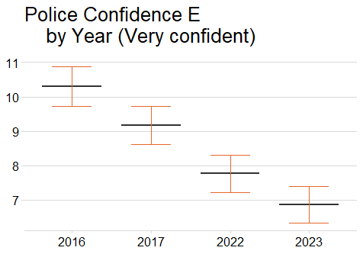

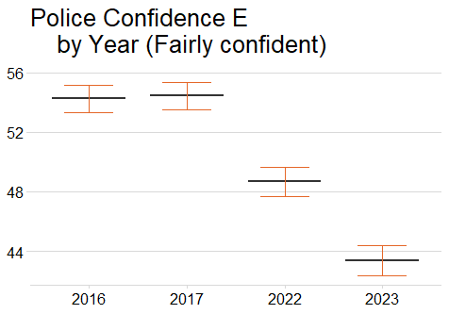

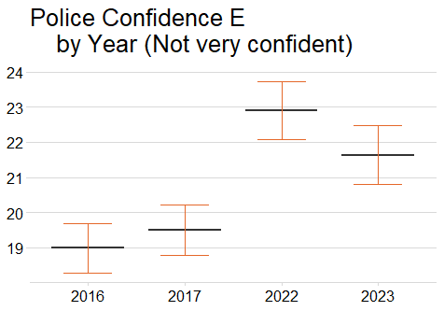

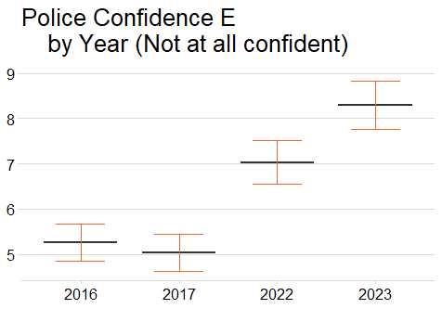

### 17.6 Police Confidence F: Catch criminals

SSCQ Respondent Police Confidence F by Year (Catch Criminals)

| Year | Very confident | Fairly confident | Not very confident | Not at all confident |
| --- | --- | --- | --- | --- |
| 2023 | 6.8 ± 0.5 | 42.4 ± 1 | 22.5 ± 0.8 | 9 ± 0.6 |
| 2022 | 7.6 ± 0.5 | 47.2 ± 1 | 25.3 ± 0.9 | 7.2 ± 0.5 |
| 2017 | 9.1 ± 0.6 | 52.4 ± 0.9 | 21.9 ± 0.8 | 5.7 ± 0.4 |
| 2016 | 10.3 ± 0.6 | 51.9 ± 0.9 | 21.1 ± 0.7 | 5.8 ± 0.4 |

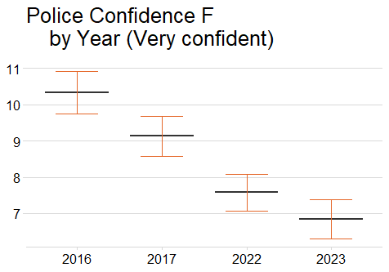

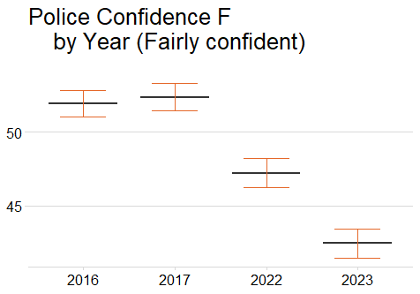

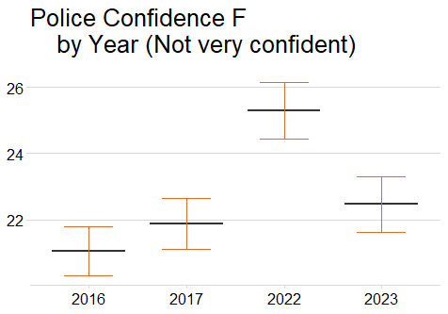

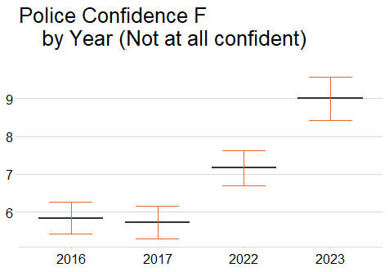

## 18. Top Qualification

This variable highlights the highest qualification that the SSCQ respondents have.

SSCQ Respondent Top Qualification by Year

| Year | Level 1 - O Grade, Standard grade or equiv (SVQ level 1 or 2) | Level 2 - Higher, A level or equivalent (SVQ Level 3) | Level 3 - HNC/HND or equivalent (SVQ Level 4) | Level 4 - Degree, Professional qualification (Above SVQ Level 4) | Other qualification | No qualifications | Qualifications not known |
| --- | --- | --- | --- | --- | --- | --- | --- |
| 2023 | 18.7 ± 0.7 | 16.2 ± 0.7 | 12.4 ± 0.6 | 36.9 ± 0.9 | 4.5 ± 0.3 | 10.9 ± 0.5 | 0 ± 0 |
| 2022 | 17.4 ± 0.7 | 15.9 ± 0.7 | 13.2 ± 0.6 | 36.8 ± 0.9 | 5.3 ± 0.4 | 10.2 ± 0.5 | 0 ± 0 |
| 2019 | 18 ± 0.7 | 16.4 ± 0.7 | 12.8 ± 0.6 | 32.4 ± 0.8 | 4.6 ± 0.3 | 15 ± 0.6 | 0 ± 0 |
| 2018 | 18.4 ± 0.7 | 16.5 ± 0.7 | 12.5 ± 0.6 | 32.1 ± 0.8 | 4.4 ± 0.3 | 15.4 ± 0.6 | 0 ± 0 |

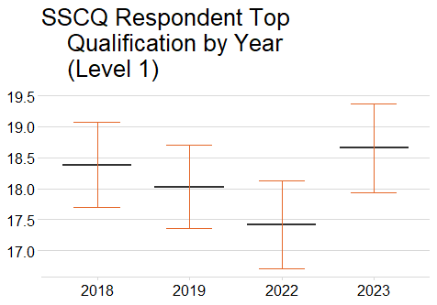

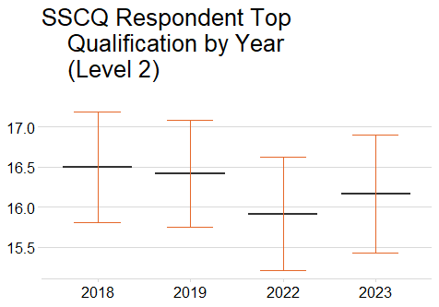

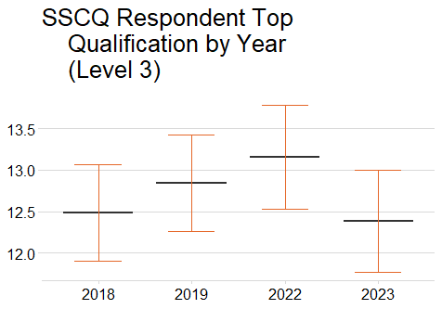

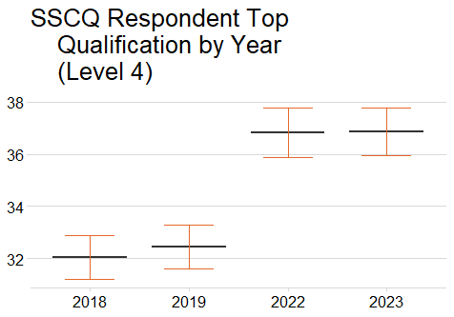

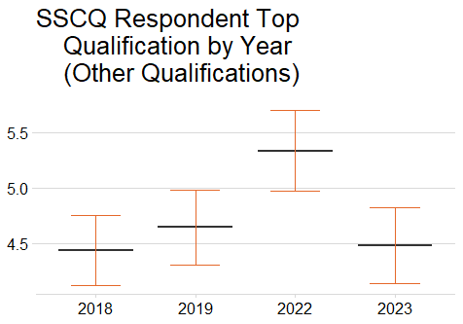

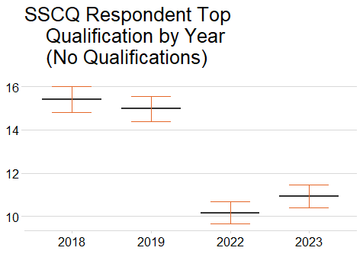

## 19. Economic Activity/Employment

This variable offers insight into the employment status of SSCQ respondents at the time of participation.

SSCQ Respondent Economic Activity by Year

| Year | In employment | ILO unemployed | Inactive |
| --- | --- | --- | --- |
| 2023 | 59.1 ± 0.9 | 1.4 ± 0.2 | 39.4 ± 0.9 |
| 2022 | 58.8 ± 0.9 | 1.6 ± 0.3 | 39.4 ± 0.9 |
| 2019 | 57.8 ± 0.8 | 2.3 ± 0.3 | 39.8 ± 0.8 |
| 2018 | 57.2 ± 0.9 | 2.1 ± 0.3 | 40.5 ± 0.9 |

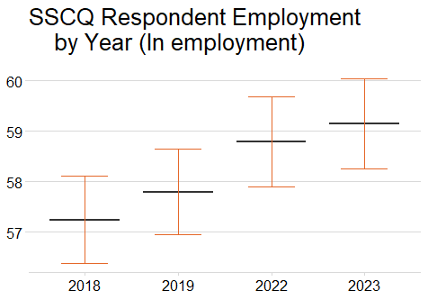

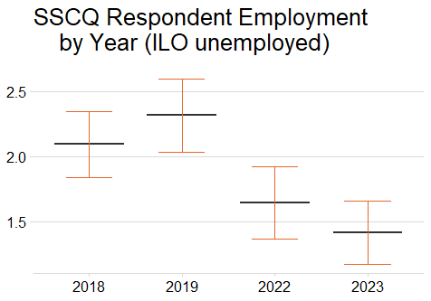

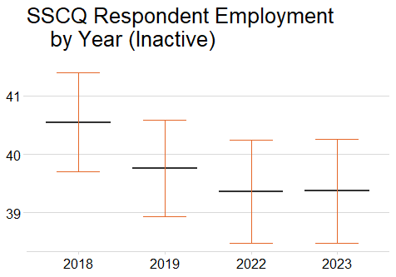

## 20. Marital Status

This variable gives a more granular analysis of the types of relationships of the SSCQ respondents are in (at the time of participation).

SSCQ Respondent Marital Status by Year

| Year | Never married and never registered a same-sex civil partnership | Married | In a registered same-sex civil partnership | Separated, but still legally married | Separated, but still legally in a same-sex civil partnership | Divorced | Formerly in a same-sex civil partnership | Widowed | Surviving partner from a same-sex civil partnership |
| --- | --- | --- | --- | --- | --- | --- | --- | --- | --- |
| 2023 | 36.3 ± 0.9 | 46.8 ± 0.9 | 0.4 ± 0.1 | 1.8 ± 0.2 | 0.2 ± 0.1 | 7.4 ± 0.4 | 0 ± 0 | 6.8 ± 0.3 | 0 ± 0.1 |
| 2022 | 37.7 ± 1 | 45.1 ± 1 | 0.2 ± 0.1 | 1.8 ± 0.2 | 0.2 ± 0.1 | 8 ± 0.4 | 0 ± 0 | 6.7 ± 0.3 | 0 ± 0 |
| 2019 | 36.4 ± 0.9 | 46.5 ± 0.9 | 0.1 ± 0.1 | 1.8 ± 0.2 | 0.2 ± 0 | 7.7 ± 0.4 | 0 ± 0 | 7.3 ± 0.3 | 0 ± 0 |
| 2018 | 36.2 ± 0.9 | 46.5 ± 0.9 | 0.2 ± 0.1 | 2 ± 0.2 | 0.2 ± 0.1 | 7.8 ± 0.4 | 0 ± 0 | 6.9 ± 0.3 | 0 ± 0 |

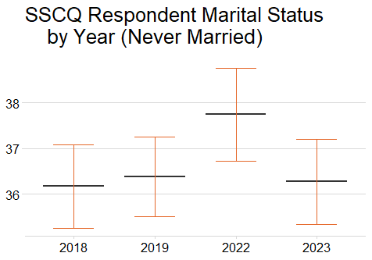

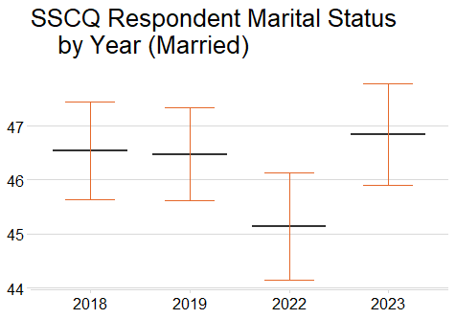

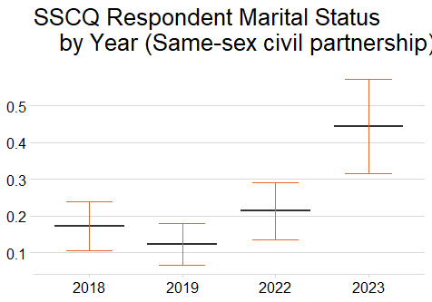

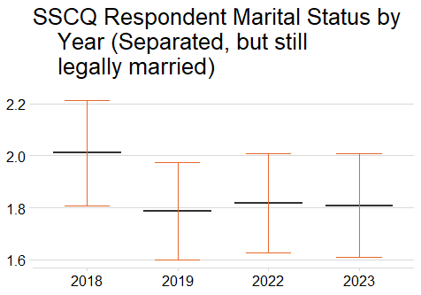

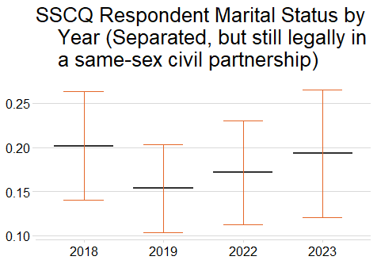

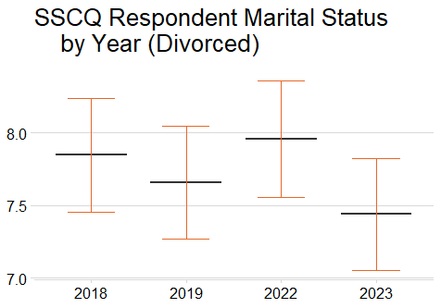

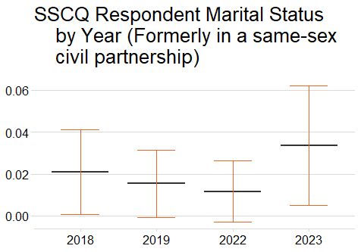

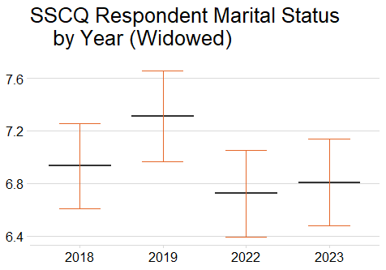

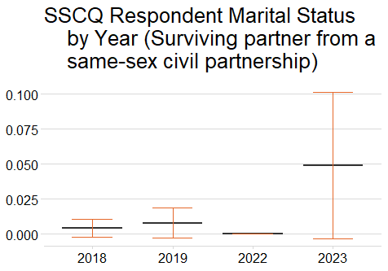

## 21. Veteran Status

This variable was only added to the Core Questions in 2022, so only 2 SSCQ years can be compared.

SSCQ Respondent Veteran Status by Year

| Year | Not a UK Armed Forces veteran | UK Armed Forces veteran |
| --- | --- | --- |
| 2023 | 96.2 ± 0.3 | 3.8 ± 0.3 |
| 2022 | 96.1 ± 0.3 | 3.9 ± 0.3 |

